**Android application that demonstrates Activity life cycle:**

**7 lifecycle methods of android activity.**

|  |  |
| --- | --- |
| **Method** | **Description** |
| **onCreate** | called when activity is first created. |
| **onStart** | called when activity is becoming visible to the user. |
| **onResume** | called when activity will start interacting with the user. |
| **onPause** | called when activity is not visible to the user. |
| **onStop** | called when activity is no longer visible to the user. |
| **onRestart** | called after your activity is stopped, prior to start. |
| **onDestroy** | called before the activity is destroyed. |

**Mainactivity.java:**

package com.example.myapplicationact;

import androidx.appcompat.app.AppCompatActivity;

import android.os.Bundle;

import android.util.Log;

public class MainActivity extends AppCompatActivity {

@Override

protected void onCreate(Bundle savedInstanceState) {

super.onCreate(savedInstanceState);

setContentView(R.layout.activity_main);

Log.d("lifecycle","onCreate invoked");

}

@Override

protected void onStart() {

super.onStart();

Log.d("lifecycle","onStart invoked");

}

@Override

protected void onResume() {

super.onResume();

Log.d("lifecycle","onResume invoked");

}

@Override

protected void onPause() {

super.onPause();

Log.d("lifecycle","onPause invoked");

}

@Override

protected void onStop() {

super.onStop();

Log.d("lifecycle","onStop invoked");

}

@Override

protected void onRestart() {

super.onRestart();

Log.d("lifecycle","onRestart invoked");

}

@Override

protected void onDestroy() {

super.onDestroy();

Log.d("lifecycle","onDestroy invoked");

}

}

**Output:**

**Step1:** Run the Program and launch your Activity in emulator

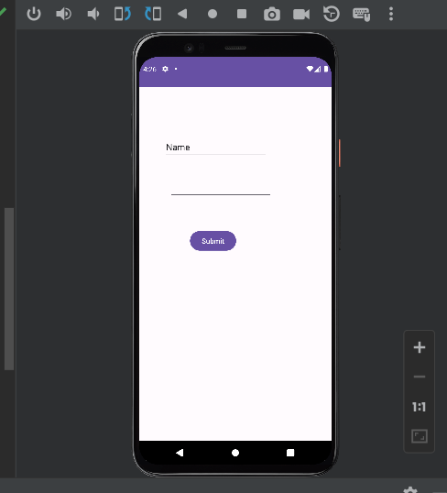

**Step2:**

Now see on the logcat: onCreate, onStart and onResume methods are invoked.



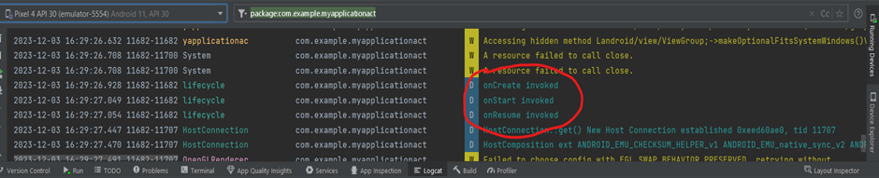

**Step3:**

Now Click on the overview button of the emulator to stop the activity

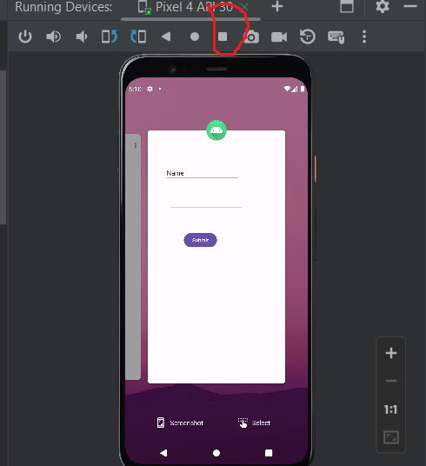



**Step4**:Once clicked note down the changes in emulator as well as in logcat window

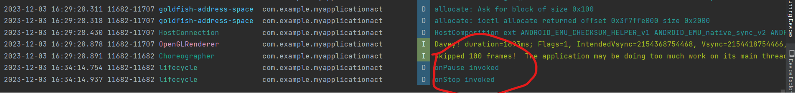

**Step5:** Again, Restart the Activity by selecting the present activity in the emulator and note down the changes in Logcat window.

**Emulator:**

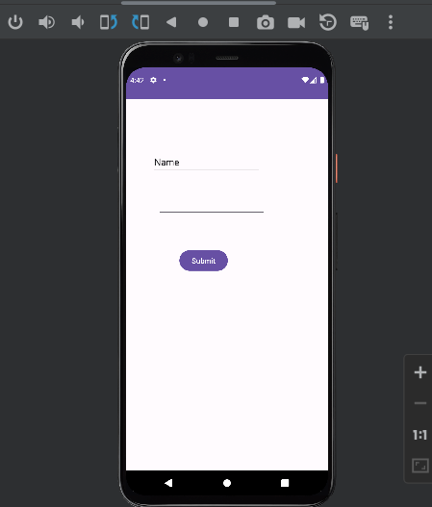

Logcat:

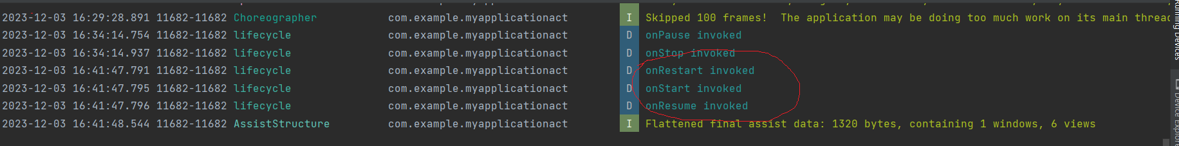

**Step6**: Again, click on the overview button of the emulator and remove the present activity and see the working of onDestroy() method

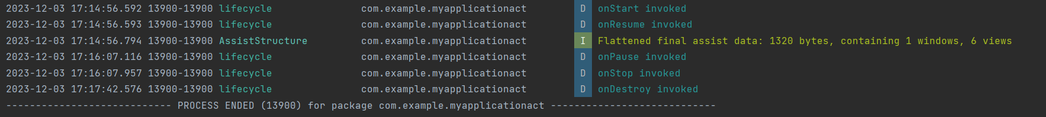



**Memory usage:**

To check the memory usage, click on the **profiler and click on + and add present emulator**

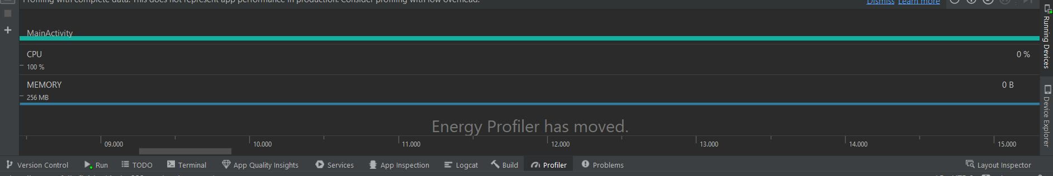



Select your emulator and check the memory allocation

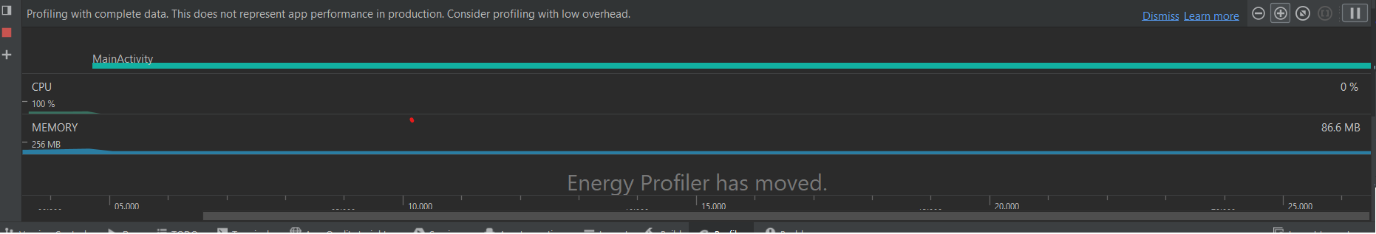



Now stop the activity and see the changes

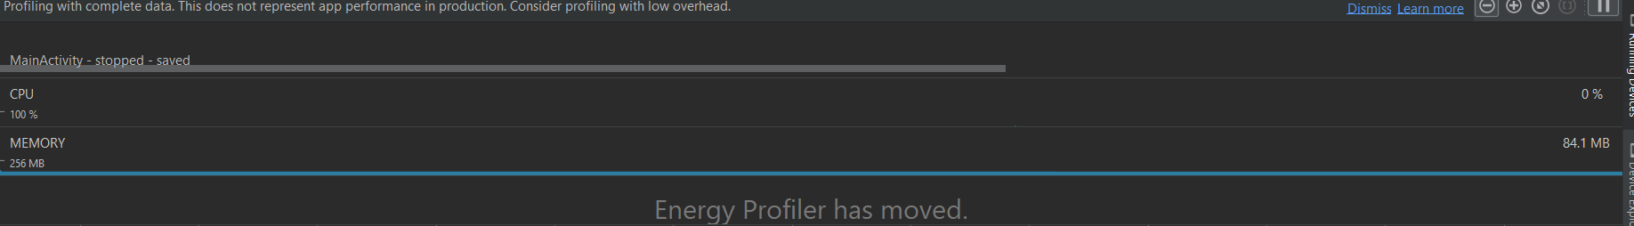



Finally delete the activity

